**ALI HASSAN 03-15211-005**

**ASSIGNMENT 3**

**TASK 1**

#include <iostream>

using namespace std;

int main() {

int val = 5;

int** arr = new int* [3];

for (int i = 0; i < 3; i++) {

arr[i] = new int[5];

}

for (int i = 0; i < 5; i++) {

for (int j = 0; j < 3; j++) {

arr[i][j] = val++ * 3;

cout << arr[i][j] << "\t";

}

cout << endl;

}

return 0;

}

**Output:**

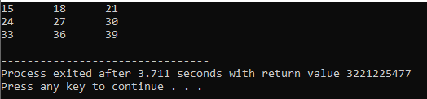

**Task 2:**

#include <iostream>

using namespace std;

class Node {

public:

int value;

Node* next;

};

int main() {

cout << "Here is the data in the array: ";

int* arr = new int[3];

for (int i = 0; i < 3; i++) {

arr[i] = i + 1;

cout << "\n" << arr[i] << "\t";

}

Node* list1, * list2, * list3;

list1 = new Node();

list2 = new Node();

list3 = new Node();

list3->next = NULL;

list1->next = list2;

list2->next = list3;

Node* temp;

temp = list1;

int count = 0;

cout << endl;

cout << "The data is from array: ";

while (temp != NULL) {

temp->value = arr[count];

count++;

cout << temp->value << "\t";

temp = temp->next;

}

return 0;

}

**Output:**

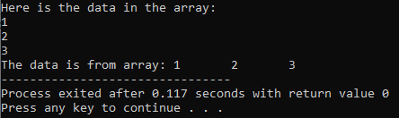

**Task 3:**

#include <iostream>

using namespace std;

class Node {

public:

int data;

Node* next;

};

int main() {

int* arr = new int[3];

Node* list_1, * list_2, * list_3;

list_1 = new Node();

list_2 = new Node();

list_3 = new Node();

list_3->next = NULL;

list_1->next = list_2;

list_2->next = list_3;

Node* temp;

temp = list_1;

int count = 0;

cout << "HERE IS THE LINKED LIST DATA: ";

while (temp != NULL) {

temp->data = count + 1;

cout << temp->data << "\t";

arr[count] = temp->data;

temp = temp->next;

count++;

}

cout << endl << "\nARRAY DATA COPIED FROM THE LIST: ";

for (int i = 0; i < 3; i++) {

cout << arr[i] << "\t";

}

return 0;

}

**Output:**

